**Wearable Usage Guide**

This guide is for users of the nimbalwear data processing pipeline. The aim is to help users understand how to configure their devices and offload their sensor data in line with the data processing pipeline.

[summary]

**Study Data Collection**

For each ***device*** worn in each data collection in the study, be sure to record the following information that will be used to verify and organize data within the pipeline:

Study Code

An alphanumeric string that uniquely identifies the current study that this data file belongs to.

Subject ID

An alphanumeric string that uniquely identifies the participant within the study. If the study includes multiple sites that may use the same Subject ID then include a Site ID to make each Subject ID unique (e.g., SBH0001 and TWH0001).

Collection ID

An alphanumeric string that uniquely identifies the collection for the participant. This is useful in repeated measures or longitudinal designs where data is collected multiple times from the same participants.

Device Location

An alphanumeric string that identifies the body location where the device was attached. [Can include default list that pipeline uses as a suggestion – I can get this –KB]

Device Type

A code that identifies the type (make/model) of the device selected from the list of codes below for devices currently supported by the NiMBaLWEAR pipeline.

* GNOR – GENEActiv Original
* BF18 – Bittium Faros 180
* BF36 – Bittium Faros 360
* AXV6 – Axivity AX6
* NOWO – Nonin WristOx2

Device ID

A unique identifier for the device such as the serial number.

For each ***subject*** in the study, be sure to record the following information that are required to perform specific analytics in the pipeline:

Study Code

An alphanumeric string that uniquely identifies the current study that this data file belongs to.

Subject ID

An alphanumeric string that uniquely identifies the participant within the study.

Age

Age at start of data collection.

Dominant hand

Subject’s dominant hand

We recommend storing this device and subject information in spreadsheet format with a column for each variable and a row for each device or subject. Because the pipeline uses the _ character as a separator when constructing file names we recommend avoiding the _ character within the elements of variables.

**Device Configuration**

The NiMBaLWEAR data processing pipeline authenticates data stored in the header of each data file to ensure data integrity. The following data are used to uniquely identify each data file in the pipeline:

Study Code, Subject ID, Collection ID

These will be entered manually during device configuration and should match exactly the information recorded above.

Device Location

For most devices, this will be selected from a list and should match exactly or map to a unique identifier for each device location used.

Device Type, Device ID

Each device stores information in the header of each data file indicating what make and model of device was used to collect the data.

Each device stores information that uniquely identifies the specific device used to collect the data including the make, model, and serial ID of the device.

We recommend following the manufacturer instructions to initialize each device in a manner that fits your particular study design. The additional instructions below can be used, at the appropriate point, to ensure that required data are entered in the appropriate location during configuration of each type of device currently supported by the NiMBaLWEAR pipeline.

*GENEActiv Original*

The following example data are used in the instructions below (see the **Study Data Collection** section for details about each item):

*Study Code*: NIM12

*Subject ID*: 85933

*Collection ID*: 01

*Device Location*: left wrist

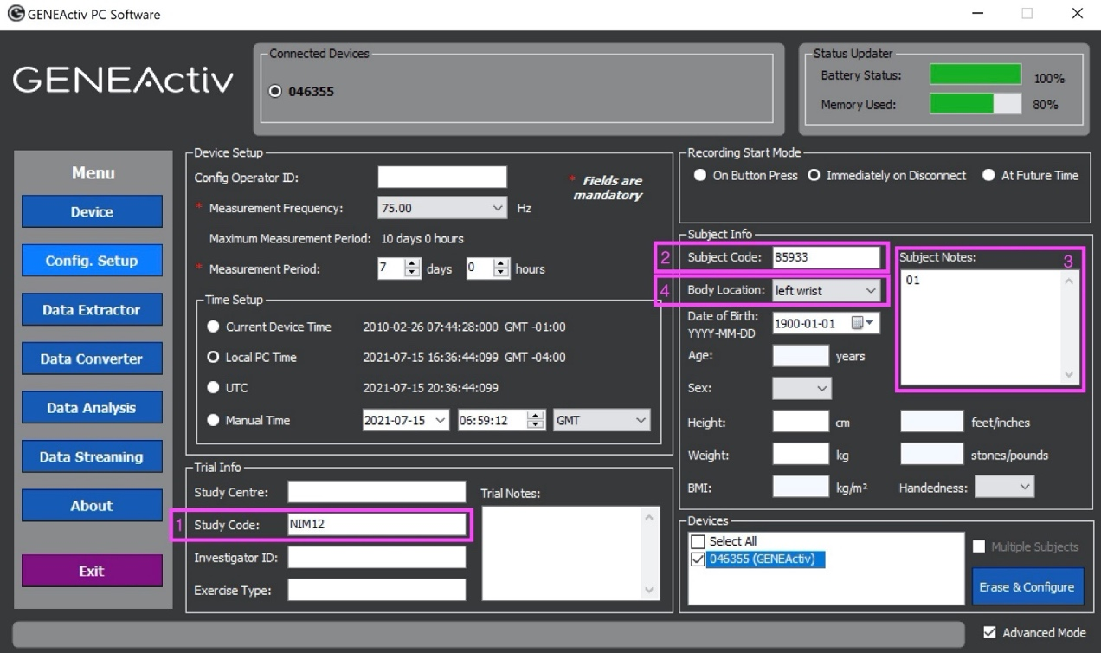

1. Enter *Study Code* in the ‘Study Code’ field.
2. Enter *Subject ID* in the ‘Subject Code’ field.
3. Enter *Collection ID* in the ‘Subject Notes’ field.
4. Select *Device Location* from the ‘Body Location’ list.

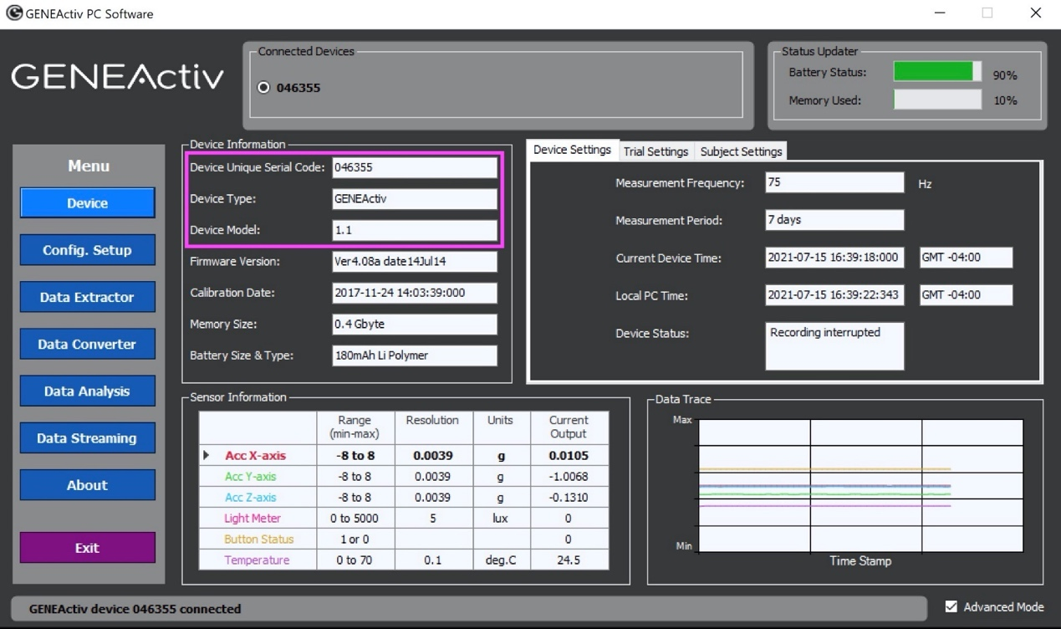

Additional header data are automatically set by the manufacturer and used by the pipeline to identify the *Device Type* and *Device ID*. For example, the ‘Device Unique Serial Code,’ ‘Device Type,’ and ‘Device Model’ are shown in the image above.

*Bittium Faros 180/360*

The following example data are used in the instructions below (see the **Study Data Collection** section for details about each item):

*Study Code*: NIM12

*Subject ID*: 85933

*Collection ID*: 01

*Device Location*: chest (assumed, no place to set this)

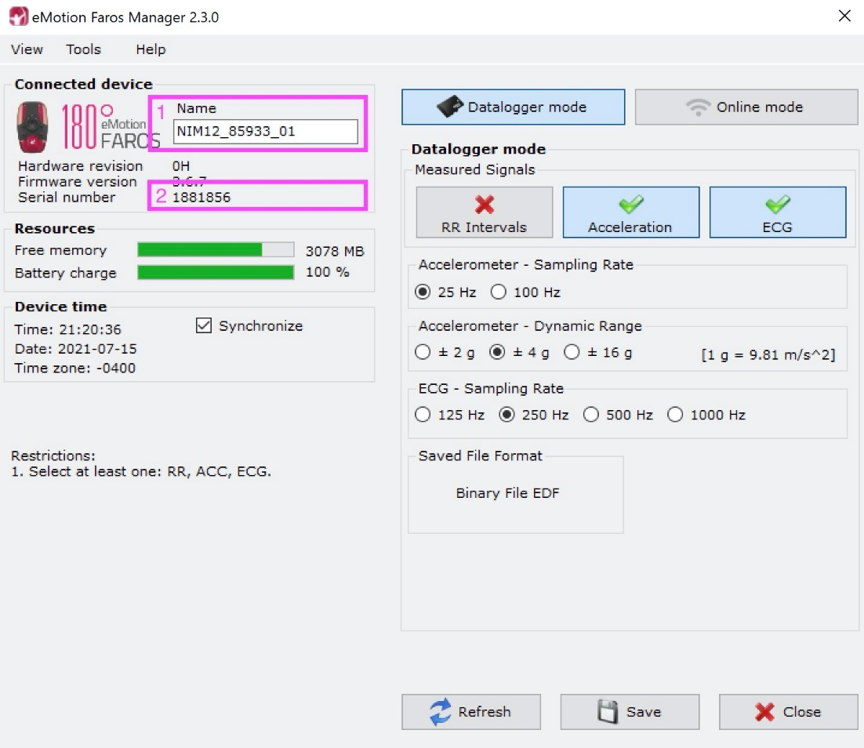

1. Only one header field is allowed to be edited during Bittium configuration so a string must be constructed that contains all of the relevant information.
   1. Construct a string that contains the *Study Code, Subject ID,* and *Collection ID*, in that order separated by underscores (_) as shown in the example above, i.e., [*Study Code*]_[*Subject* ID]_[*Collection ID*].
   2. Enter the string in the ‘Name’ field.
   3. For Bittium devices, *Device Location* is assumed to be ‘chest’ and does not need to be entered.
2. Additional header data are automatically set by the manufacturer and used by the pipeline to identify the *Device Type* and *Device ID*. Only the ‘Serial number’ is displayed during configuration.

*Axivity AX6*

The following example data are used in the instructions below (see the **Study Data Collection** section for details about each item):

*Study Code*: NIM12

*Subject ID*: 85933

*Collection ID*: 01

*Device Location*: left ankle

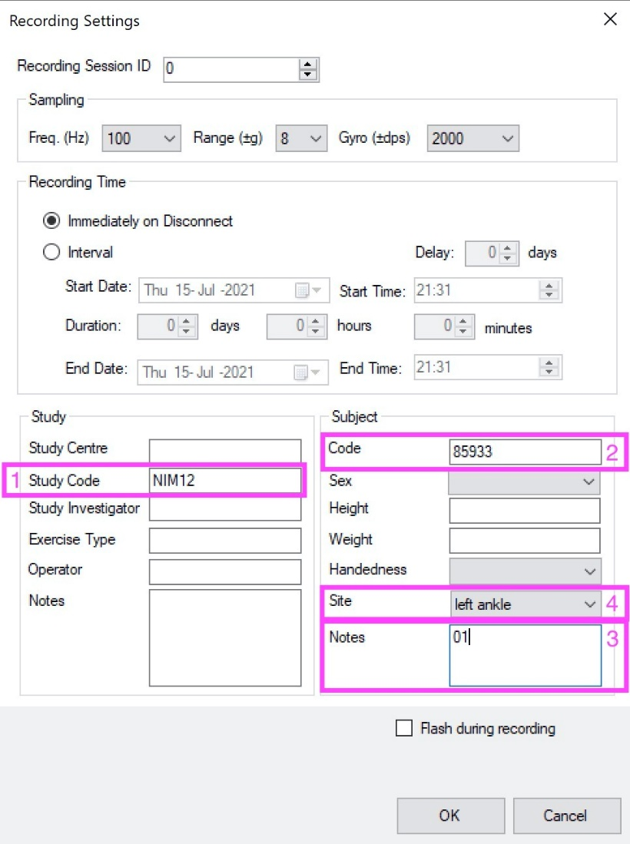

1. Enter *Study Code* in the ‘Study Code’ field in the ‘Study’ section.
2. Enter *Subject ID* in the ‘Code’ field in the ‘Subject’ section.
3. Enter *Collection ID* in the ‘Notes’ field in the ‘Subject’ section.
4. Select *Device Location* from the ‘Site’ list in the ‘Subject’ section.

Additional header data are automatically set by the manufacturer and used by the pipeline identify the *Device Type* and *Device ID* but are not displayed during configuration.

**Device Data Retrieval**

We recommend following the manufacturer instructions to retrieve data from each device into a single common study folder as that is the way the “raw” wearable data will be stored as input into the pipeline. Therefore, it is necessary for each file to be named or renamed in a way that uniquely identifies it within the context of your study (without requiring additional subfolders).

Any unique file names will work but we recommend the following convention for simplicity and human readability.

STUDY_SUBJECT_COLL_DEVTYPE_DEVLOC.EXT

Where the components represent the data outlined in the **Study Data Collection** section as follows:

STUDY: Study Code

SUBJECT: Subject ID

COLL: Collection ID

DEVTYPE: Device Type

DEVLOC: Device Location

EXT: The device specific file extension

**NOTE:** For some devices, GENEActiv in particular, clock drift is measured at the time of data offload by comparing the elapsed time on the device clock to the elapsed time on the computer the device was initialized on and offloaded to. For these devices, it is important that they are initialized and offloaded on the same computer and that no major adjustment to the computer clock has occurred (e.g., a time zone change including to or from Daylight Savings Time).

**Appendix: Raw data file header info**

**Header data used in pipeline to validate files**

study_code : unique identifier for the study

subject_id : unique identifier for the subject

coll_id : unique identifier for the collection (visit, condition, etc.)

device_type : make/model or unique identifier for the device

device_location : location on the body that the device was worn

device_id : unique device identifier, usually serial ID

**Location of data in device file headers**

|  |  |  |  |  |
| --- | --- | --- | --- | --- |
|  | NW EDF | GENEActiv | Bittium | Axivity |
| study_code | admincode | ‘Study Code’ | patientcode | metadata/study_code |
| subject_id | patientcode | ‘Subject Code’ | patientcode | metadata/subject_code |
| coll_id | patient_additional | ‘Subject Notes’ | patientcode | Metadata/_sn |
| device_type | equipment | Constant | equipment | device_type |
| device_location | recording_additional | ‘Device Location Code’ | Constant(‘Chest’) | metadata/body_location |
| device_id | equipment | ‘Device Unique Serial Code’ | equipment | device_id |